ITA0305- Mobile Computing
LAB EXPERIMENT
Name: G.Ganesh
Reg NO:192373008

18. Simulate a basic ad hoc network using a networking tool.

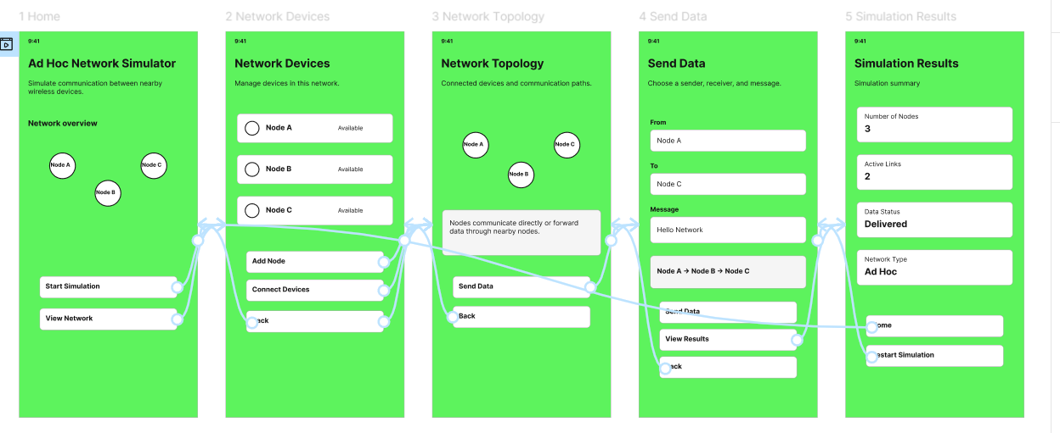

https://www.figma.com/design/ptL1gbbVldIh4M4sme7L2E/program18?node-id=0-1&p=f&t=k7QKZoW3lWZl4ez3-0

